SOP: QC Report Overview and QA Agent Audit
Module | QC Report Overview and QA Agent Audit
Who uses it | Project Manager, Assistant Manager, Admin, Super Admin
Version | 1.0
Issued | 21 Oct 2026
Screenshots are taken from the HRMS test copy. Names, dates and numbers are examples only.

1. Purpose
QC Report Overview shows every QC result with its errors, files and correction / rework history. QA Agent Audit lets managers re-check QA work and record an audit score.

2. QC Report Overview
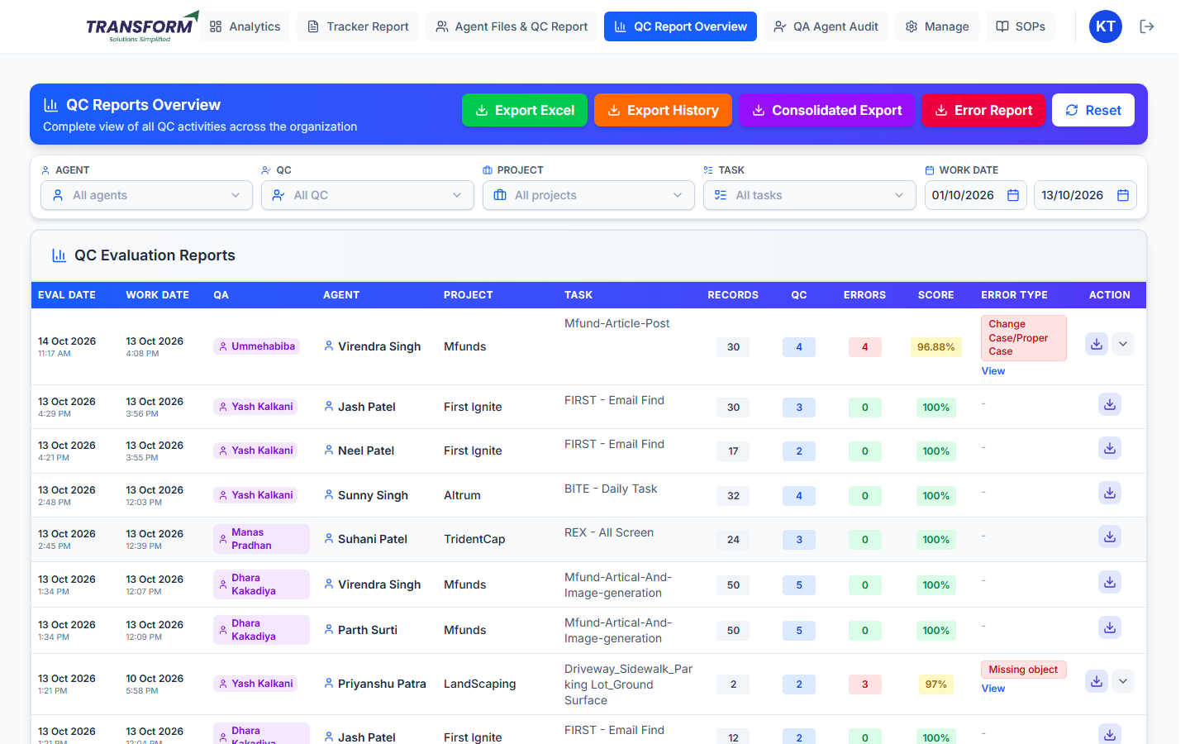
Figure 1: QC Report Overview
Part | What it shows / does
Agent / QC / Project / Task / Work Date | Filters. Work Date is the agent's file date (current month to today by default). Reset clears them.
Eval Date / Work Date | When QC was done / the file's work date.
QA / Agent / Project / Task | Who checked, whose file, and for what.
Records / QC / Errors / Score | Rows in the file, rows checked, errors found, QC score.
Error Type | The error names; View lists each error with its QC code and points.
Action - download | The QC file QA checked: sample plus added rows, error rows highlighted, errors in the last column.
Action - arrow | Opens Rework & Correction History.

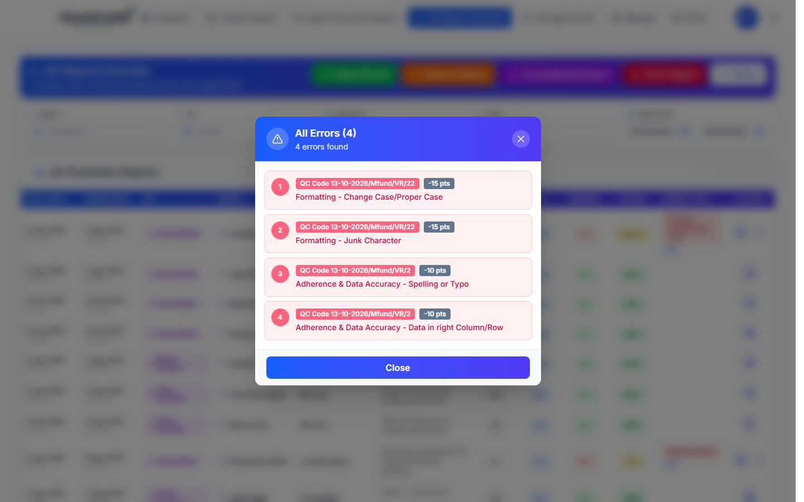
Figure 2: View - the errors of a QC
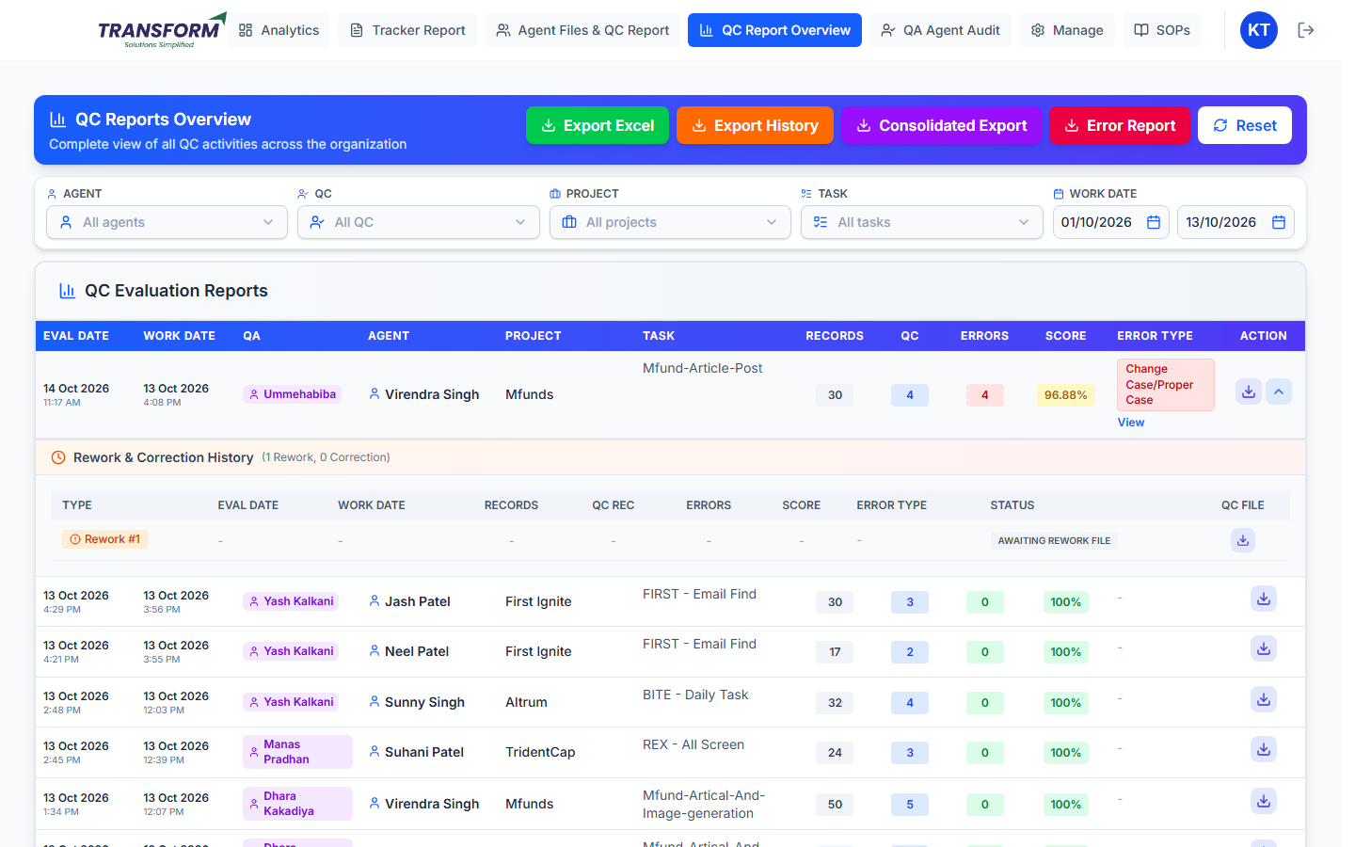
Figure 3: Rework & Correction History of a file

2.1 Exports
Button | What you get
Export Excel | The table as shown (filters applied).
Export History | Every rework and correction cycle.
Consolidated Export | One summary row per file for the dates.
Error Report | Only files with errors: each error type with how many times it appears in each file.

3. QA Agent Audit

3.1 Audit a QA's work
1. Open QA Agent Audit > QA Agent Audit Form. Each QA shows their records, total QC records and average score. Search a QA and filter by worked date and QC date.
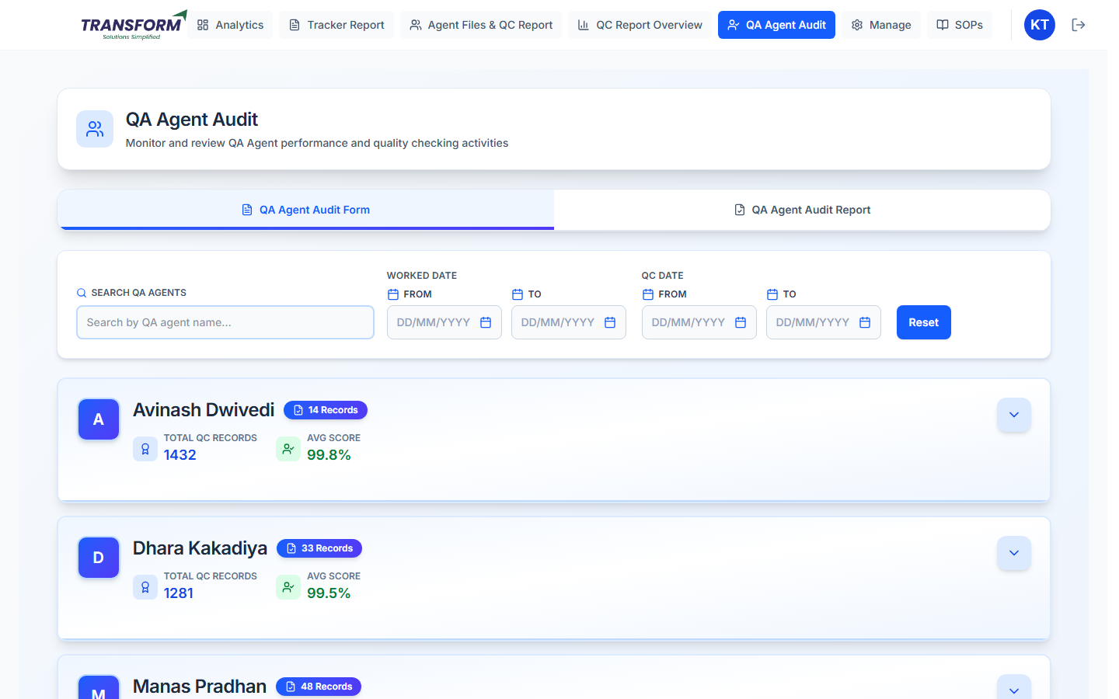
Figure 4: QA Agent Audit Form
2. Open a QA with the arrow to list their QC records (worked date, QC date, agent, project, task, QC file, file record count, error list, QC score).
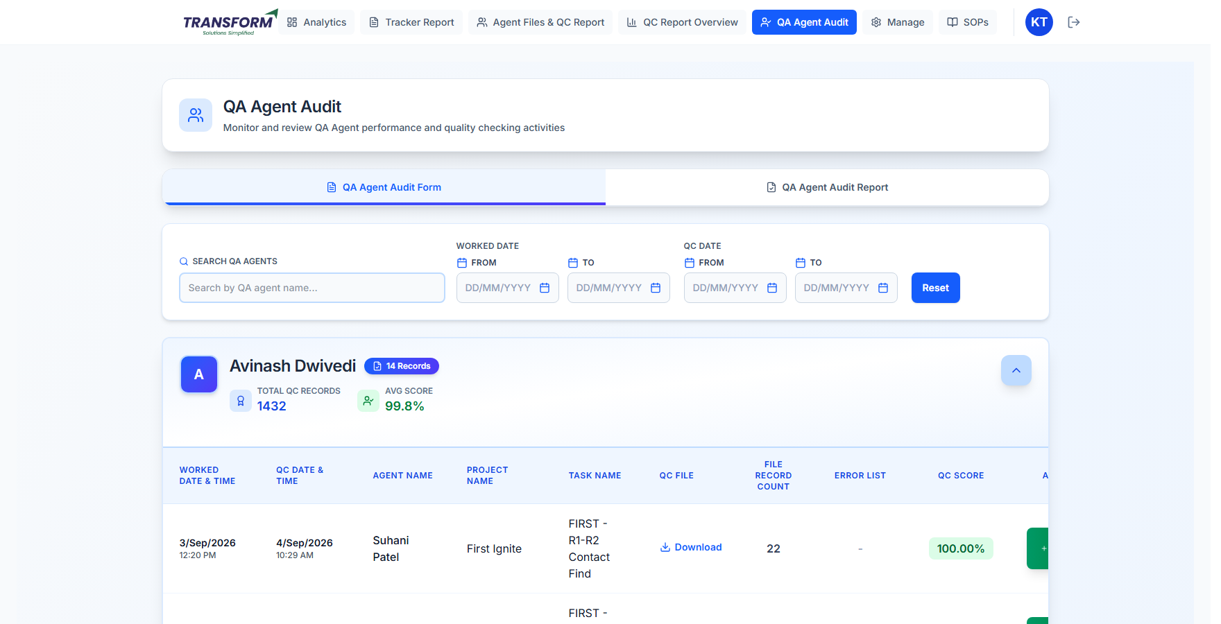
Figure 5: A QA's QC records
3. Click the green button on a record. Enter the audit QC Score (0-100), attach the QC checked file if any, add Error Notes and click Submit Score.
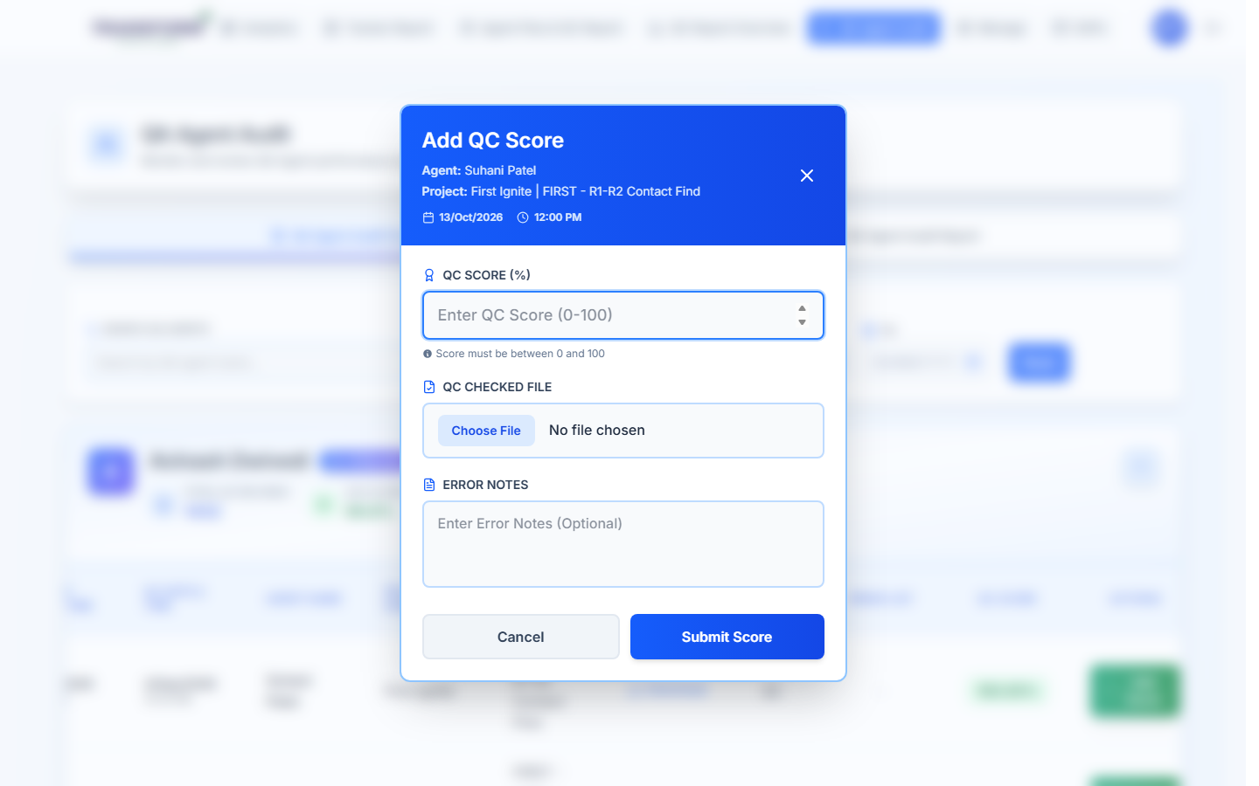
Figure 6: Add QC Score (audit)

3.2 Audit report
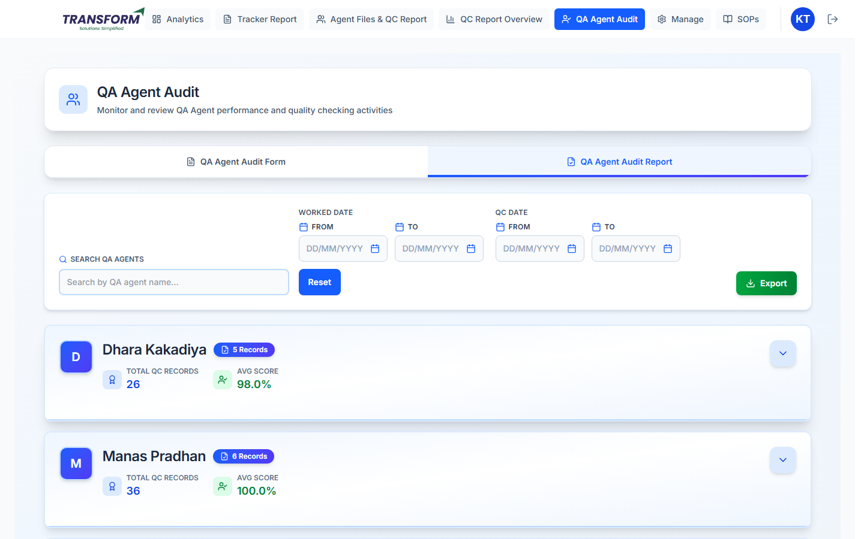
Figure 7: QA Agent Audit Report
All audits done, to compare the QA's score with the audit score.

4. Common problems
Problem | What to do
Score shows 0% with no errors | Report it to the HRMS team with the tracker number.
File not in the list | Check the Work Date range - it is the agent's file date, not the QC date.
Download gives an old-format file | Files saved before the update keep the old layout.

